**Integrate TF Mini LiDAR with Cube Ardupilot (Mission Planner)**

**1. Connect TF Mini LiDAR to Cube Ardupilot**

* Power: Connect VCC (5V) and GND to the corresponding power pins on the Cube.
* Communication: TF Mini LiDAR can use UART (Serial) or I2C. The recommended approach is UART (Serial).
  + TF Mini UART Mode Pinout:
    - LiDAR TX → Cube Ardupilot RX (Serial Port)
    - LiDAR RX → Cube Ardupilot TX (Serial Port)

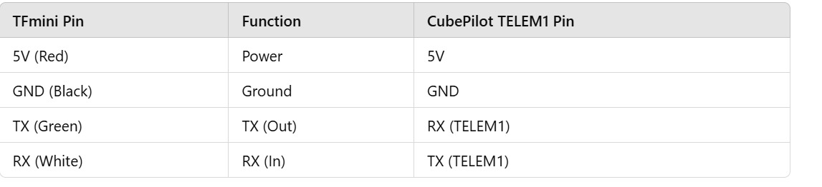

**2. Configure Serial Port in Ardupilot**

* Open Mission Planner and go to:

CONFIG → Full Parameter List

* Set the serial port where your TF Mini is connected (usually SERIAL4 or SERIAL2).

SERIALx_PROTOCOL = 9 (Lidar)

SERIALx_BAUD = 115 (For 115200 baud rate)

*(Replace x with the port number where your LiDAR is connected.)*

**3. Configure Rangefinder Parameters**

* In Mission Planner, search for RNGFND1 parameters and set:

RNGFND1_TYPE = 20 (TF Mini)

RNGFND1_MIN_CM = 30

RNGFND1_MAX_CM = 1200 (Depends on TF Mini model)

RNGFND1_SCALING = 1

RNGFND1_GNDCLEAR = 10 (Modify based on your drone's mounting height)

*(If using UART, set RNGFND1_ADDR = 0.)*

**4. Verify in Mission Planner**

* Restart your Cube Ardupilot.
* Go to Flight Data → Status Tab.
* Look for the sonar_range value. It should show real-time distance readings from the TF Mini.

